EXPERIMENT 14 — TCL COMMANDS: COMMIT, SAVEPOINT, ROLLBACK
The manual says the aim is to learn COMMIT, SAVEPOINT and ROLLBACK. It explains that TCL commands manage changes made by DML statements and group them into transactions.
The manual's original example uses a CLASS table, performs an UPDATE, creates savepoints A, B, and C, and then uses rollback to return to earlier points.
We will do the same experiment using your Juice Shop database, but in a separate table so your previous juiceshopc table is not damaged.

Create a separate table for Experiment 14
We will call it juice_tcl.
DROP TABLE IF EXISTS juice_tcl;

CREATE TABLE juice_tcl (
customer_name VARCHAR(30),
token_no INT,
juice_name VARCHAR(30),
no_of_juices INT
);
STEP 3 — Insert initial records
INSERT INTO juice_tcl
(customer_name, token_no, juice_name, no_of_juices)
VALUES
('G.Chakri', 321, 'Orange', 3),
('Rani', 323, 'Banana', 5),
('veKiran', 324, 'Mango', 2);

STEP 4 — Display the initial table
SELECT * FROM juice_tcl;
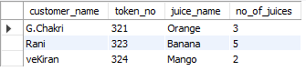

STEP 5 — Start the transaction
This is important because we want ROLLBACK and SAVEPOINT to work on the changes.
START TRANSACTION;

STEP 6 — Update a record
Change G.Chakri's number of juices from 3 to 4.
UPDATE juice_tcl
SET no_of_juices = 4
WHERE token_no = 321;

Check it:
SELECT * FROM juice_tcl;

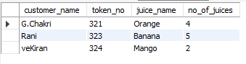

Create SAVEPOINT A
SAVEPOINT A;
This creates a temporary point to which we can later roll back. The manual describes SAVEPOINT as temporarily saving a transaction so that it can be rolled back to that point.

Insert another customer
INSERT INTO juice_tcl
(customer_name, token_no, juice_name, no_of_juices)
VALUES
('Gopi', 327, 'Apple', 3);
Check:
SELECT * FROM juice_tcl;
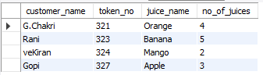
Insert another customer
INSERT INTO juice_tcl
(customer_name, token_no, juice_name, no_of_juices)
VALUES
('Vasavi', 328, 'Mango', 3);
Check:
SELECT * FROM juice_tcl;
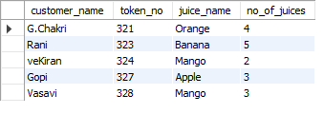

Create SAVEPOINT C
SAVEPOINT C;

STEP 12 — Test ROLLBACK TO B
Now remove the changes made after B.
ROLLBACK TO SAVEPOINT B;
Then:
SELECT * FROM juice_tcl;
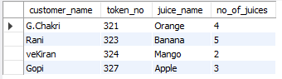
STEP 13 — Test ROLLBACK TO A
Now roll back further:
ROLLBACK TO SAVEPOINT A;
Then:
SELECT * FROM juice_tcl;
COMMIT the final state
Now permanently save the remaining transaction changes:
COMMIT;
Verify after COMMIT
Run:
SELECT * FROM juice_tcl;
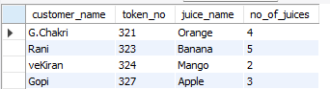

RESULT
The TCL commands COMMIT, SAVEPOINT, and ROLLBACK were successfully implemented and the results were verified.

